This is a sample write-up. The write-up need not be in tabular form.

It doesn’t state that ConvLSTM will give you better results than Conv3D. The explanation should be as detailed as possible so that the logic behind the decision is conveyed. Also, there are a lot of things you can experiment with in the generator function and elsewhere. Please do not forget to specify the exact metric values, here Accuracy which drives your decision.

You can draw inspiration from the concepts taught in the Industry demo in CNNs to experiment with the data and different architectures.

|  |  |  |  |
| --- | --- | --- | --- |
| **Experiment Number** | **Model** | **Result** | **Decision + Explanation** |
| **1** | **Conv3D** | **Throws Generator error** | **Crop the images correctly, try to overfit on less amount of data** |
| **2** | **Conv3D** | **Model not trainable as a lot of parameters** | **Reduce the size of the image/Reduce the number of layers** |
| **3** | **Conv3D** | **Accuracy: 0.21** | **Increase the amount of trainable data/ reduce the filter size** |
|  |  |  |  |
|  |  |  |  |
| **2** | **Conv3D** | **Accuracy: 0.32** | **Reduce Cropping** |
| **3** | **Conv3D** | **Accuracy : 0.38** | **………………** |
|  |  |  |  |
| **l-1th** | **Conv3D** | **Accuracy: 0.45** | **Try ConvLSTM as Conv3D not giving desired accuracy** |
| **lth** | **ConvLSTM** | **Accuracy: …….** | **…………..** |
|  |  |  |  |
| **Final Model** | **……………….** | **………….** | **…………………** |

Experiment 1

Experiment 2

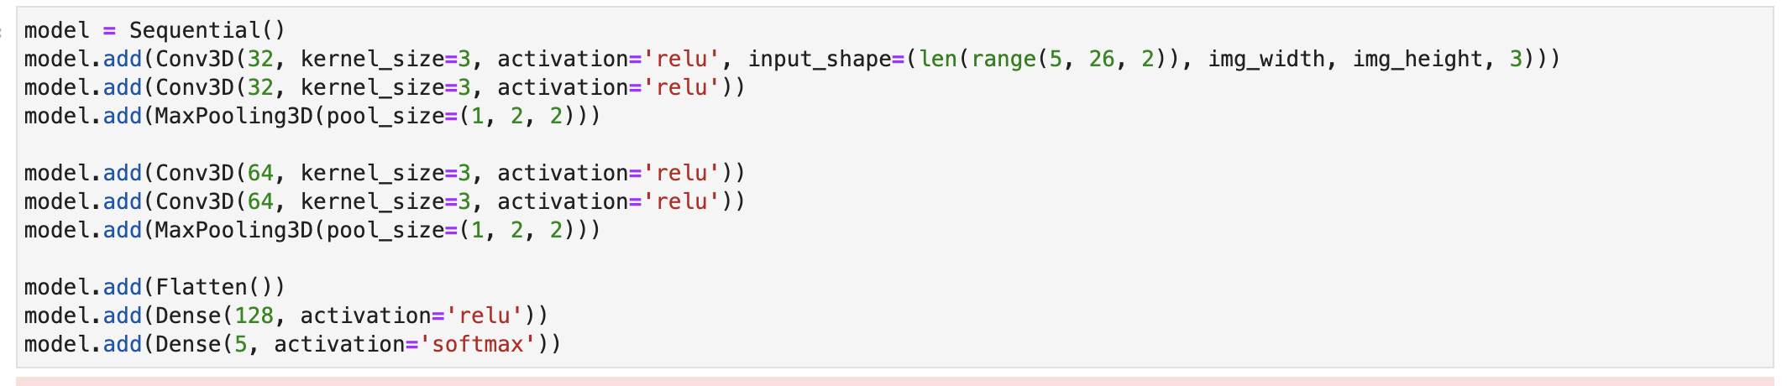

Experiment 3

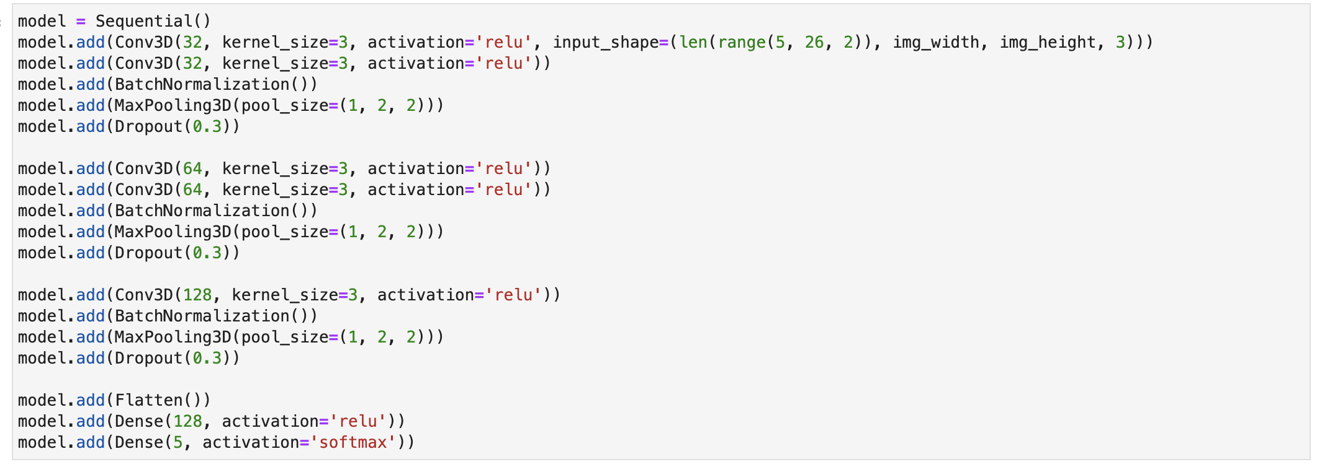

Experiment 4

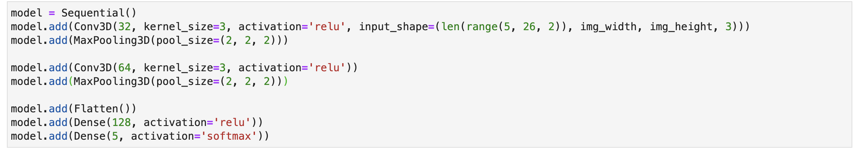

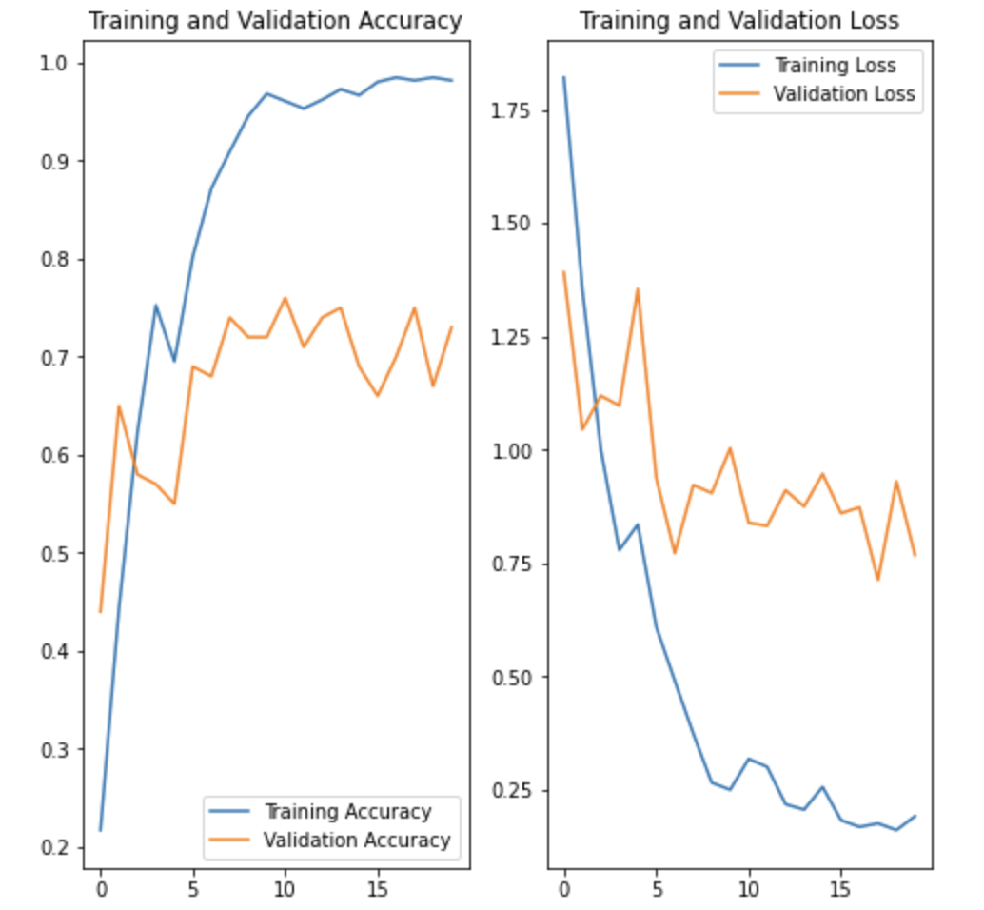

sgd

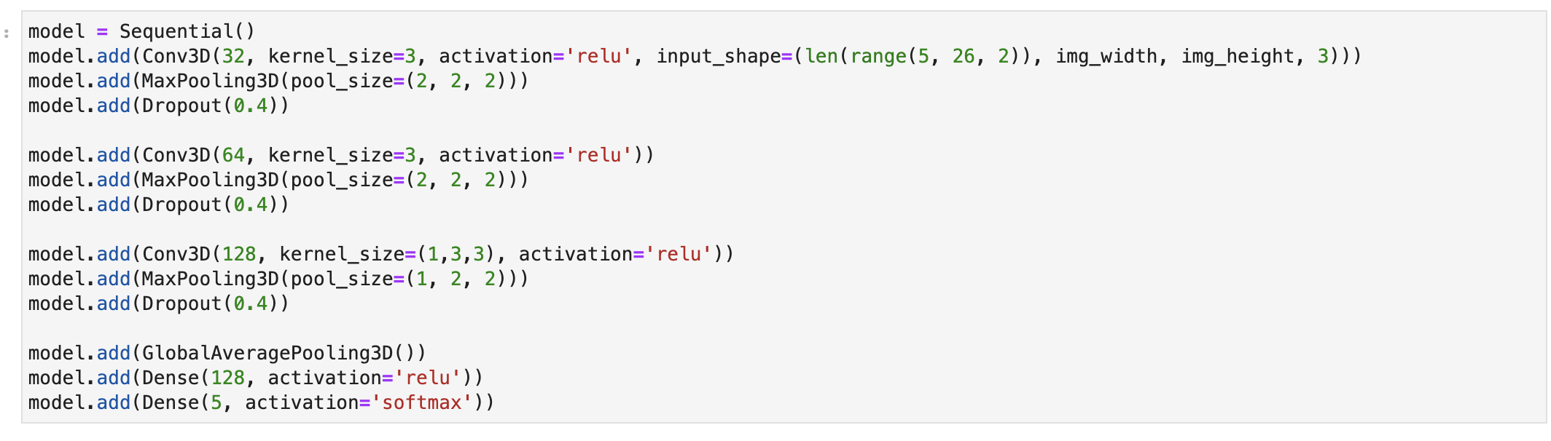

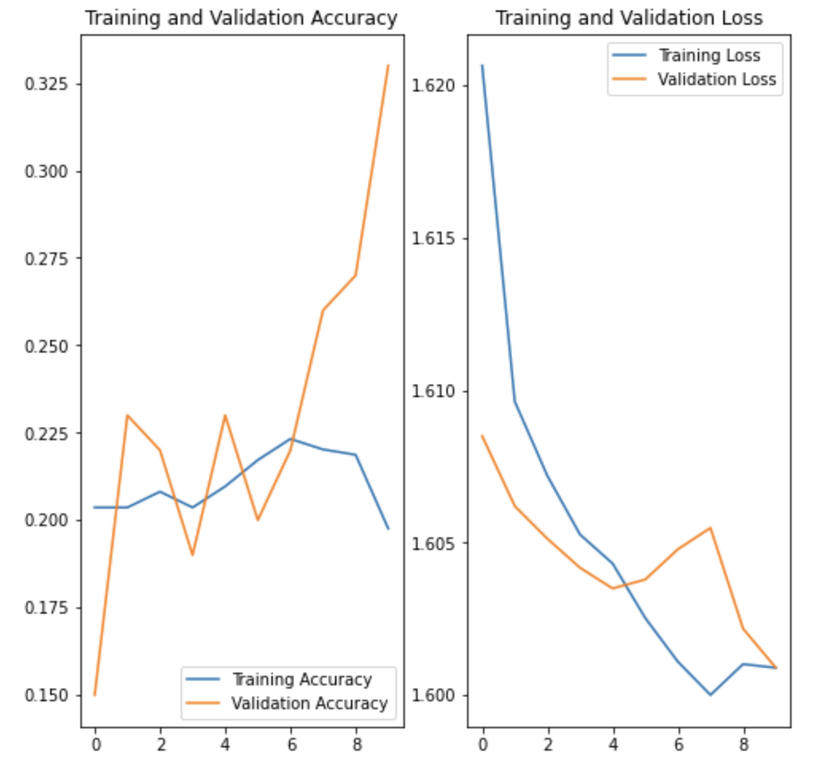

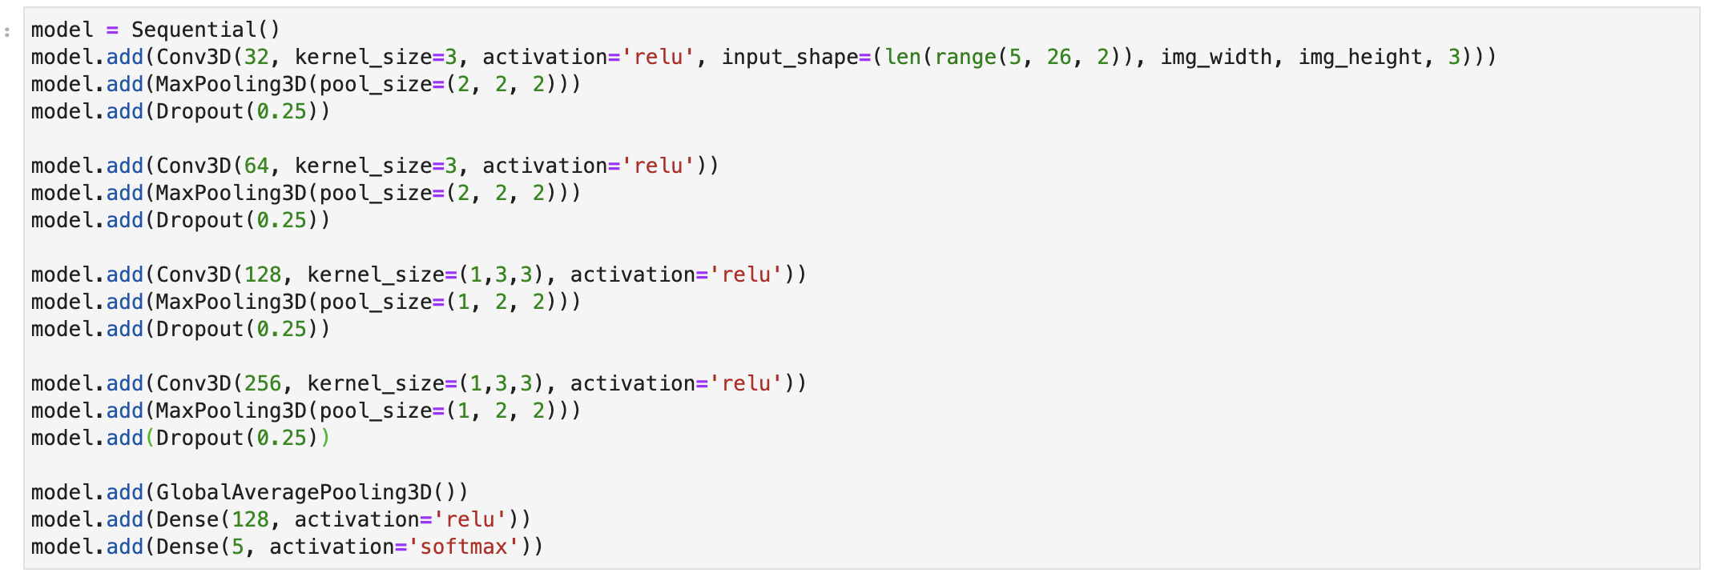

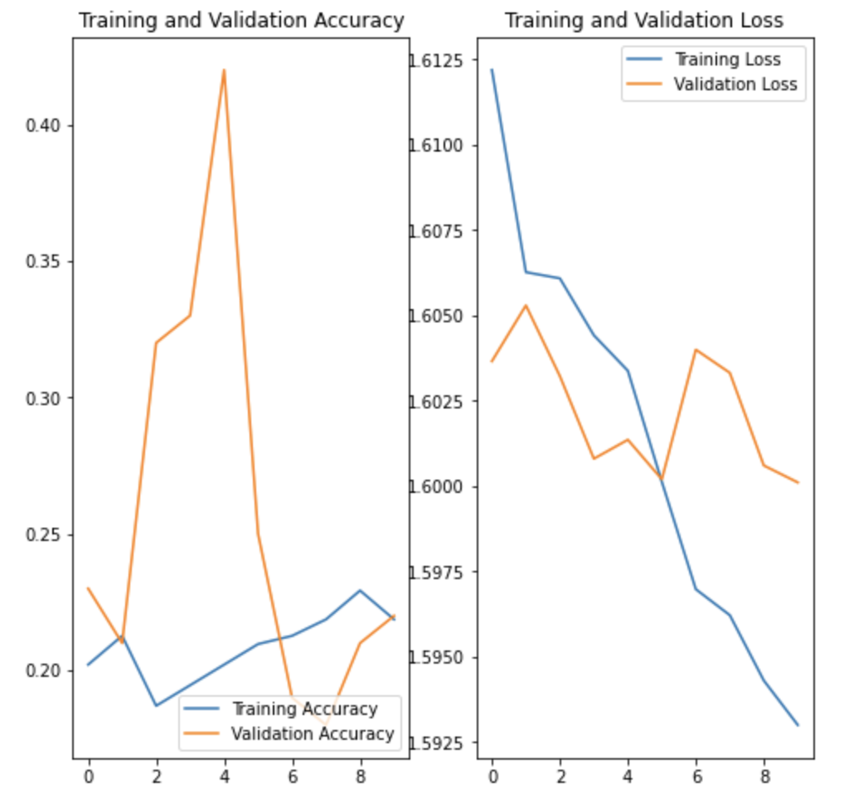

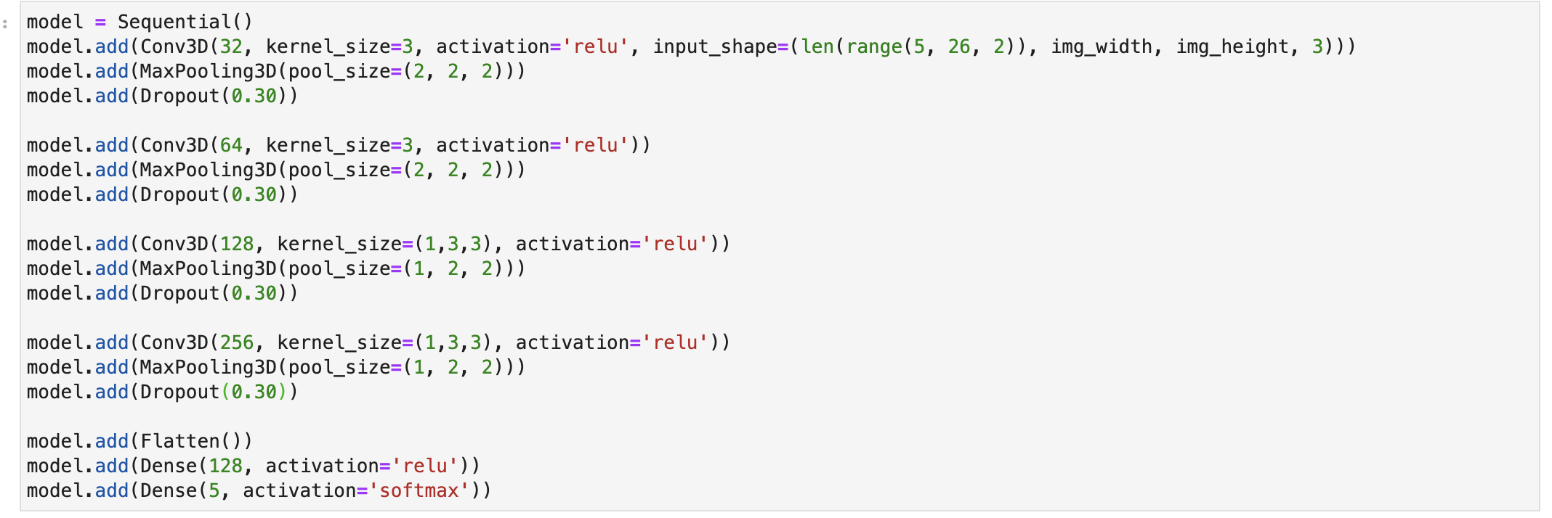

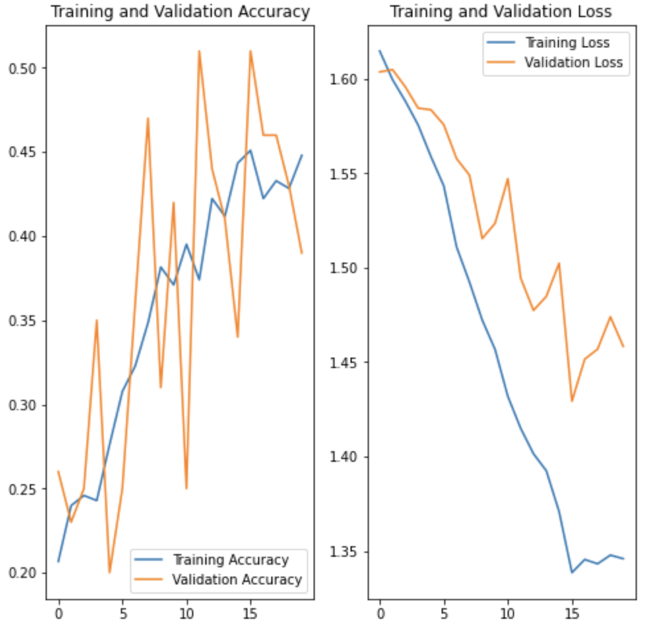

Adam

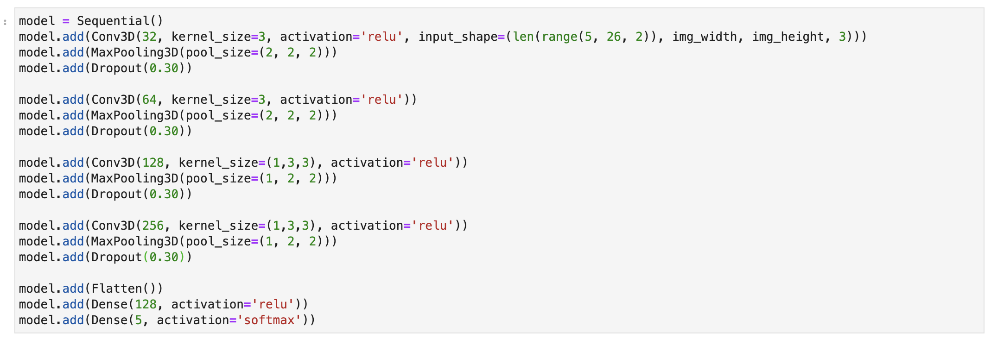

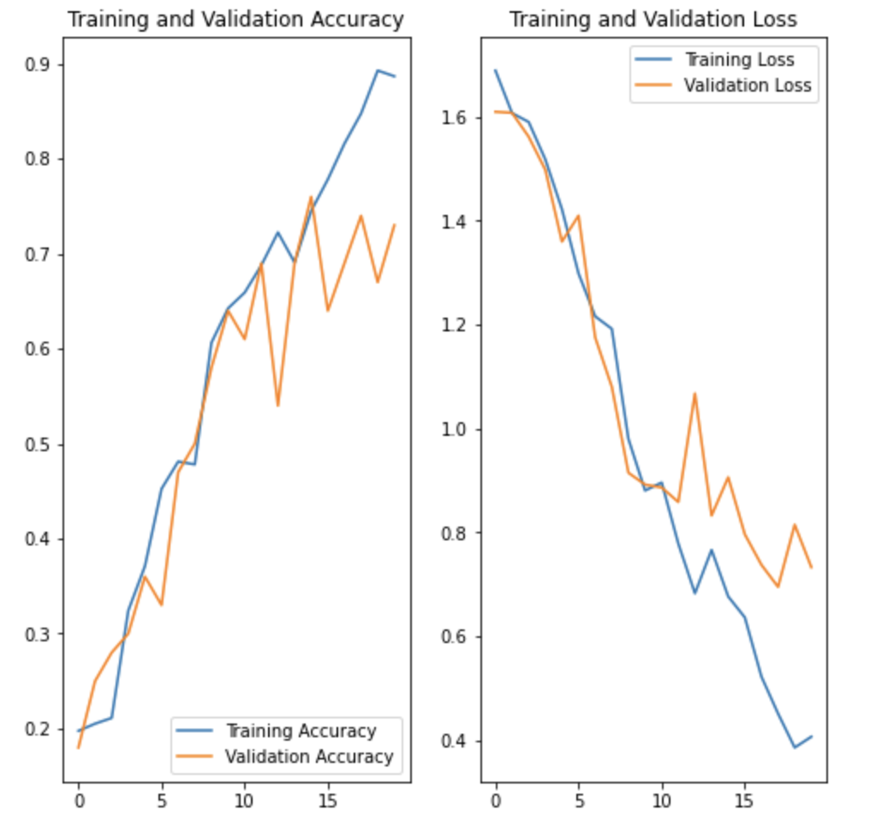

GRU

